Here is what I did to get putty working under windows. I used the Amazon Deep Learning AMI as was talked about in the recitation. Your mileage may vary depending on versions of Putty, etc. but I think this will help.

Find you hostname

In the EC2 console for you instance.

[ubuntu@ <your](mailto:ubuntu@ec2-13-58-77-229.us-east-2.compute.amazonaws.com) instance public DNS >

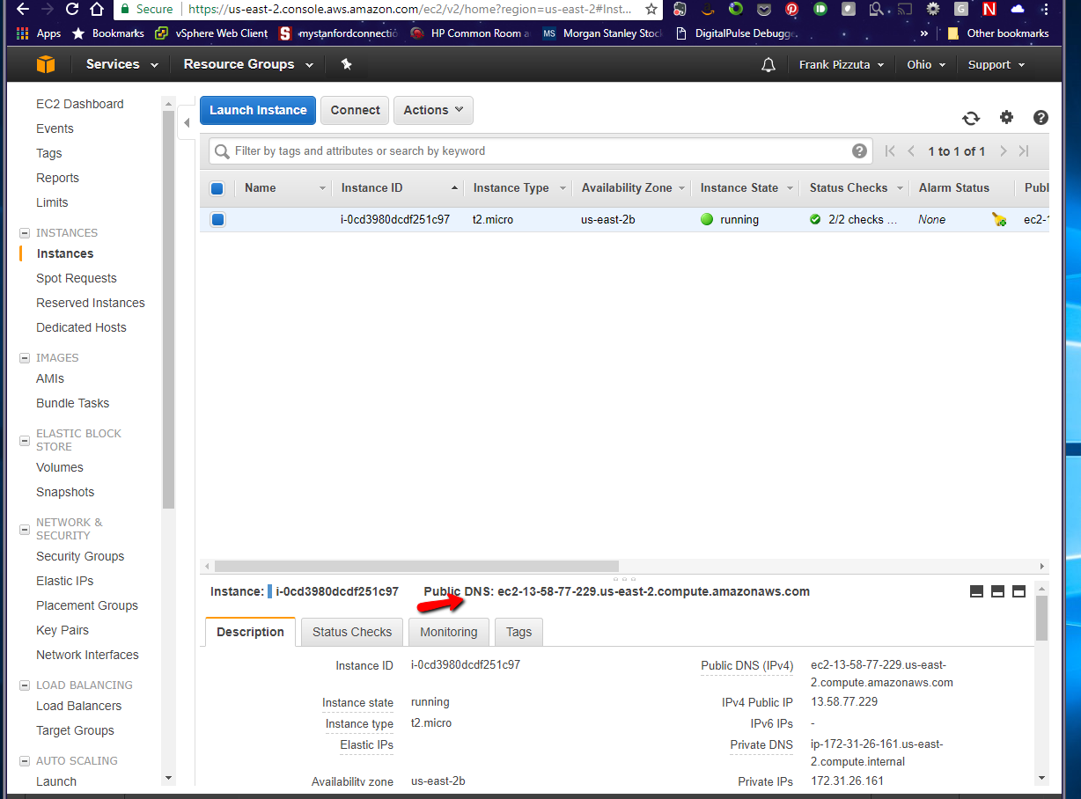

Put that value in

sessions - hostname

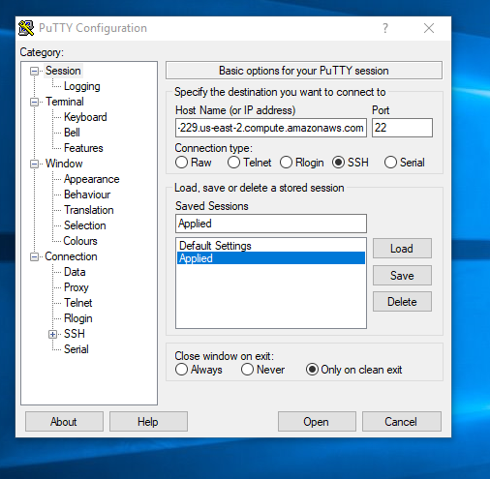

Under Connection – SSH – Tunnels

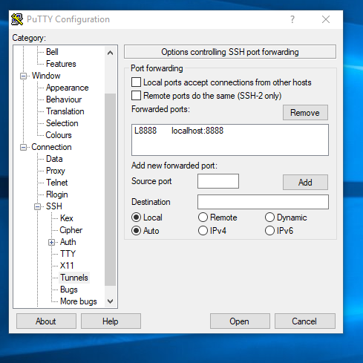

For source port enter 8888

For destination port enter localhost:8888

Hit add

Under Connection – SSH – Auth

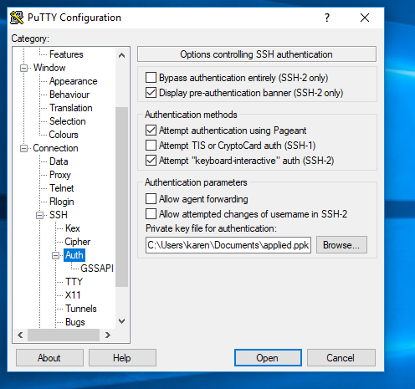

Browse for the ppk file you generated from the amazon pem file. Good instructions here <http://www.thegeekstuff.com/2017/02/aws-ec2-pem-to-ppk-putty/> or search on amazon ec2 puttygen.

Dont forget to pick a name under Sessions - Saved Sesssions and hit save. Next time you come in you will need to load the session by name and reconnect. I called my Applied.

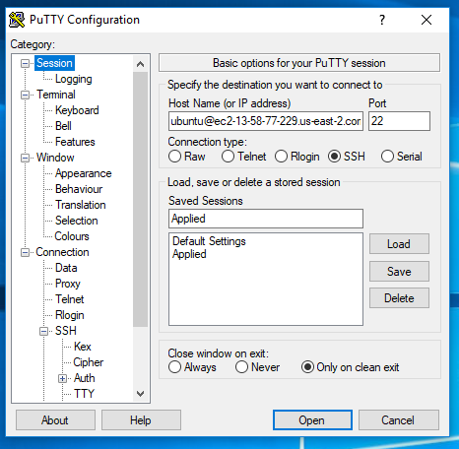

When you click open you will probably receive a security alert. Just click yes.

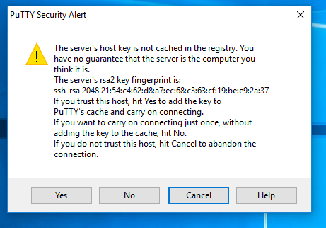

If all is well a command prompt will pop up. This is where you type jupyter notebook –no-browser

It should run a bunch of stuff and the last line will be you URL to connect to the notebook. Copy and paste this into your browser. I have it highlighted below.

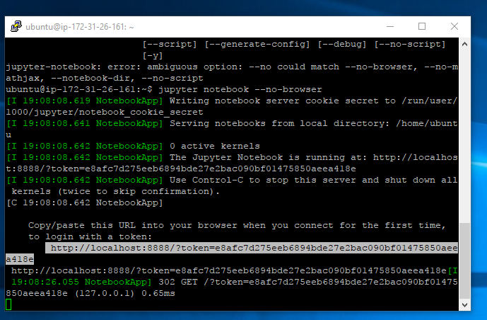

Once in your browser you should get

